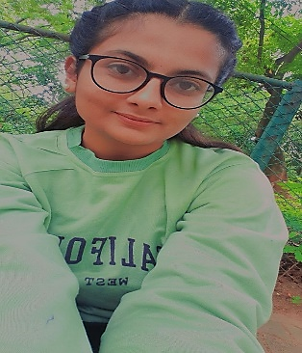 ***SWAPNA T R***

**OBJECTIVES**

To secure a challenging and rewarding position. Utilizing the talent in me for the better cause and never stop learning. Giving 100% in everything and working by combining both hard work and smart work.

**SKILLS**

* I have Computer skills where I can perform word, excel, PowerPoint.
* Listening skills.
* Communication skills.
* Problem solving.
* Leadership skills.

**EXPERIENCE**

Fresher

**COMMUNICATION**

Kannada, Telugu, English, broken Hindi.

**LEADERSHIP SKILLS**

Even though I am a fresher I believe that I have a leadership quality because I was a leader in my class during my high school education and in my UG. I leaded people with different mindsets, opinion etc.

**CONTACT**

PH NO :- 6363441695

E-MAIL :-swapnatrswapnatr@gmail.com

ADDRESS: -Thiruvaranga Village Hoskote Taluk Bangaluru Rural District-560067

**HOBBIES**

DANCING, SINGING, DRAWING, CRAFT WORK etc...

**EDUCATION**

I completed my SSLC (secondary school learning certificate) in Government High School, Chikkathirupathi in 2018-19.

I later joined Reddy Jana Sanga PU College, Koramangala to pursue my PU in PCMB and I completed it in 2020-21

I done my under graduation in BSc computer science at Maharani Cluster University, Sheshadripuram Road. I completed it in 2023-24